Linear Regression Interpretation
For Product 1, the linear model shows that rain matters the most. On rainy days, sales drop by about 2.74 units. The rain amount (precipitation) also has a negative effect, with a coefficient of about −2.20. Temperature has a small negative effect too, around −0.17 units for each 1°F increase. The R² is about 0.018, so weather only explains a small part of the changes in sales, but the signs are clear: cooler and drier days are better for this product.
For Product 2, the weather effects are very weak. The temperature coefficient is about −0.04 and the rain amount is about −1.20, but the overall R² is only about 0.0036. That means weather almost does not explain the sales at all. The weekend coefficient is about +2.62, so weekends give a small boost in sales, but weather itself is not a strong driver here.
For Product 3, rainy days reduce sales by about 1.85 units. Temperature has a tiny positive coefficient of about +0.04, which is so small that it is not very meaningful. The R² is about 0.0067, so again, weather explains very little of the variation. The weekend effect is stronger, with a coefficient of about +3.55, showing that people buy more of this product on weekends than weekdays.

Decision Tree Interpretation
The decision tree for Product 1 is very simple but still useful. It makes one split on temperature at about 54.5°F. When the average temperature is below 54.5°F, the average sales are higher, around 25.9 units. When the temperature is 54.5°F or higher, the average sales drop to about 17.3 units. This supports the regression result that cooler days are better for Product 1.
For Product 2, the tree has only one node and no splits. The root node has an average of about 15.7 units sold. This means the tree could not find any weather rule that improved predictions. So there is no clear weather pattern for Product 2.
For Product 3, the tree is also just a single node. The root node has an average of about 17 units sold. Again, there are no splits, which tells us that weather does not create strong or clear groups in the data for this product. The tree is basically saying “just predict the average” for all days.

Model Performance Comparison
For all three products, the linear regression models perform slightly better than the decision trees. For Product 1, the linear model has an RMSE of about 27.55 on the test set, while the tree has about 27.61. For Product 2, the linear RMSE is about 24.57 and the tree is about 24.60. For Product 3, the linear RMSE is about 24.07 and the tree is about 24.16. The differences are small, but the linear models are always a bit better.
The R² values are low for all products. Product 1 has the highest R² at about 0.018. Product 2 has about 0.0036 and Product 3 has about 0.0067. This means that weather explains only a tiny part of the changes in sales. Still, the linear models are more helpful than the trees, because they show the size and direction of each effect, even if the effects are small.

RMSE Validation Performance
To further evaluate model performance on unseen data, validation RMSE was also calculated for each product.
For Product 1, the linear regression model achieved a validation RMSE of 27.46, compared to 27.51 for the decision tree.
For Product 2, the linear model had a validation RMSE of 24.52, while the tree had 24.58.
For Product 3, the linear model achieved 24.05, compared to 24.12 for the tree.
These results are consistent with the test set findings. The linear regression model performs slightly better across all products, although the differences remain small. This suggests that both models have similar predictive ability, with linear regression having a slight advantage.

Conclusion
In summary, weather has a modest impact on Product 1, and a very small impact on Products 2 and 3. Product 1 sells better on cooler, dry days and worse when it rains. Product 2 is almost completely unaffected by weather and behaves like a steady, everyday product. Product 3 is slightly sensitive to rain, with lower sales on wet days, but temperature does not matter much.
Across all three products, weekends are more important than weather. Weekend sales are higher for every product, especially Product 3. The models show that while weather can nudge sales up or down a bit, it is not the main driver. These findings suggest that stock and promotion plans should focus more on weekends and product type, and only adjust for weather in a small, careful way, mainly for Product 1.

1. Temperature vs Sales Scatter Plot (All Products)
This plot shows how sales change as the temperature goes up or down.
Product 1 The dots lean slightly downward. When the weather gets warmer, sales drop a little. This matches the negative temperature coefficient in the model.
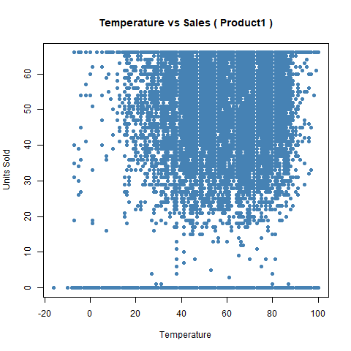

Product 2 The dots look almost flat. There is no real pattern. This fits the model too, because the temperature effect was almost zero.
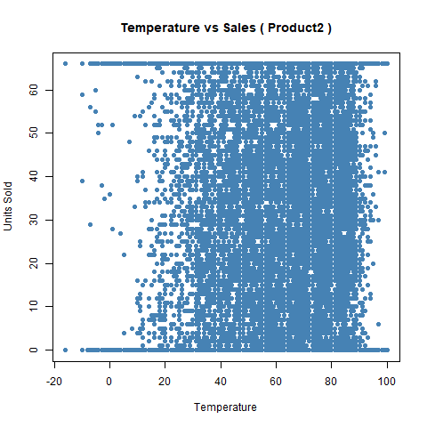

Product 3 The dots also look flat. There is no strong link between temperature and sales. The tiny positive coefficient in the model is too small to see in the plot.
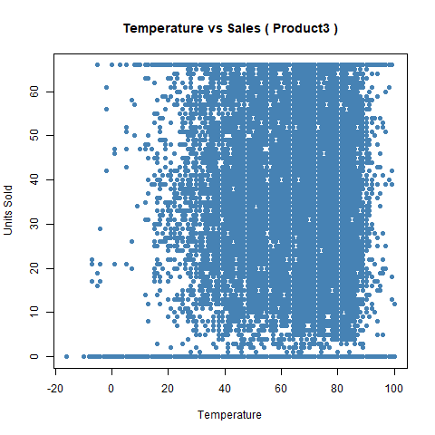

2. Rainy vs Non-Rainy Days Boxplot (All Products)
This plot compares sales on rainy days and dry days.
Product 1 The rainy-day box is lower. Sales drop when it rains. This matches the model, which showed a drop of about 2.7 units.
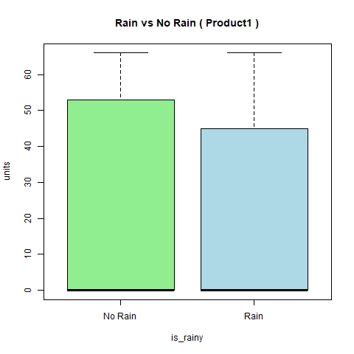

Product 2 The rainy and dry boxes look almost the same. Rain does not change sales much. This matches the near-zero rain effect in the model.
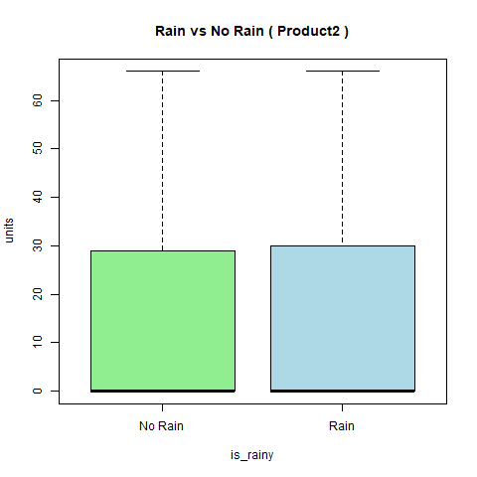

Product 3 The rainy-day box is a bit lower. Rain reduces sales by about 1.85 units. The plot shows this small dip clearly.
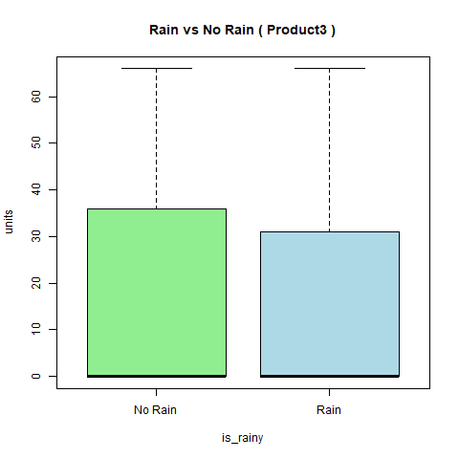

3. Weekend vs Weekday Boxplot (All Products)
This plot shows how sales change on weekends.
Product 1 The weekend box is higher. Sales rise on weekends by about 2.6 units.
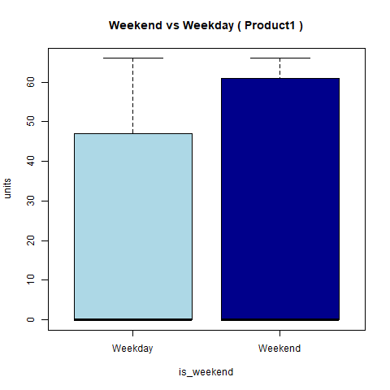

Product 2 The weekend box is also higher. The weekend effect is the main driver for this product.
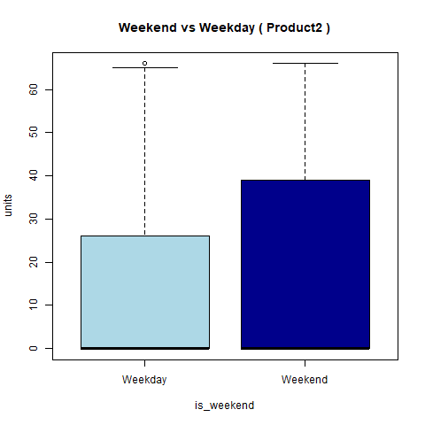

Product 3 The weekend box is the highest of all three products. Sales jump by about 3.55 units. This is the strongest weekend effect in the whole dataset.
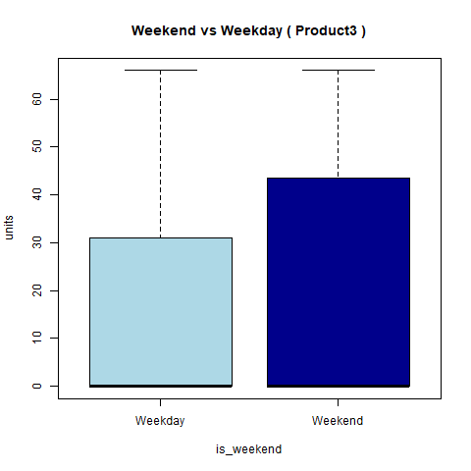

4. Sales Over Time Line Plot (All Products)
This plot shows how sales move across the year.
Product 1 There are ups and downs, but they do not match weather changes very clearly. This fits the low R² value.
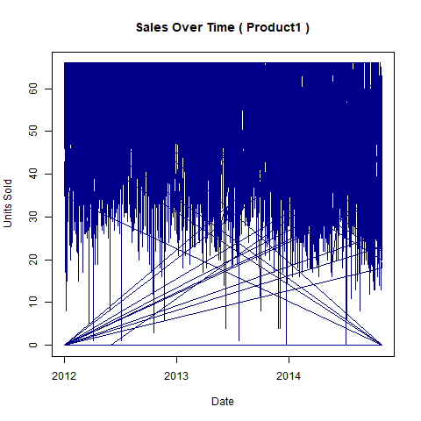

Product 2 The line is fairly steady. No big swings. This matches the idea that weather does not affect this product much.
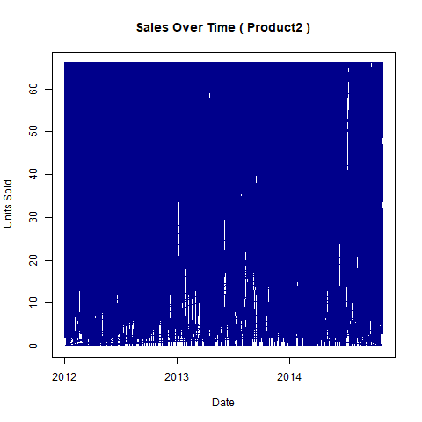

Product 3 There are some bumps, but again, nothing that lines up with weather patterns. The model also showed weak weather effects.
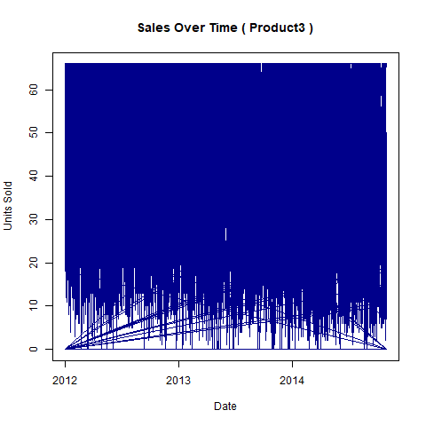

5. Decision Tree Plots (All Products)
These plots show how the tree splits the data.
Product 1 The tree makes one split at about 54.5°F. Cooler days have higher sales. This supports the regression results.
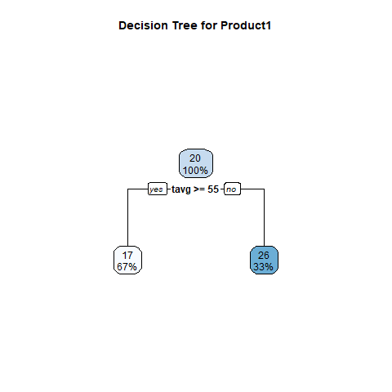

Product 2 The tree has no splits. It stays as one node. This means weather does not help predict sales.
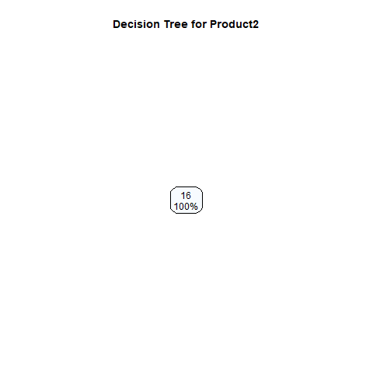

Product 3 The tree also has no splits. Again, weather does not create strong groups for this product.
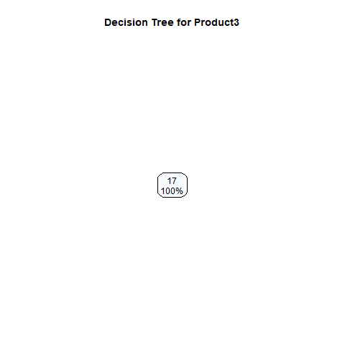

Business Recommendations
Product 1
• Increase stock by about 15 to 20 percent on cool and dry days. Sales are higher when the temperature is below 54.5°F.
• Reduce stock by around 10% on rainy days. Rain reduces sales by about 2.7 units.
• Use small promotions on rainy days only to reduce leftover stock. They will not fully fix the drop because fewer people visit the store when it rains.
Product 2
• Keep stock steady during the week. Weather does not change sales for this product.
• Add about 10% more stock for weekends. Sales rise by about 2.6 units on weekends.
Product 3
• Reduce stock by 5% - 10% on rainy days. Rain reduces sales by about 1.85 units.
• Increase stock by 15 to 20% before weekends. Weekends increases sales by about 3.55 units, which is the biggest effect for this product.

